**Water Quality Parameter Trends in the Afan River (2000–2023)**

**Introduction**:  
This appendix presents detailed visualizations of the key water quality parameters measured across the upstream, midstream, and downstream stations of the Afan River from 2000 to 2023. Parameters include **Solids, Suspended at 105°C**, **Temperature of Water**, **Oxygen, Dissolved, % Saturation**, **Copper, Dissolved**, **Calcium**, **Magnesium**, **pH**, **Carbon, Organic, Dissolved (DOC)**, and **Iron, Dissolved**. The graphs illustrate seasonal and spatial variations, highlighting trends and interconnections between stations. These visualizations provide further insight into the analysis discussed in the report's summary, showing how upstream conditions influence downstream water quality.

(1) Measurement parameters shared by the upper, middle and downstream three stations (3) :

Solids, Suspended at 105 C

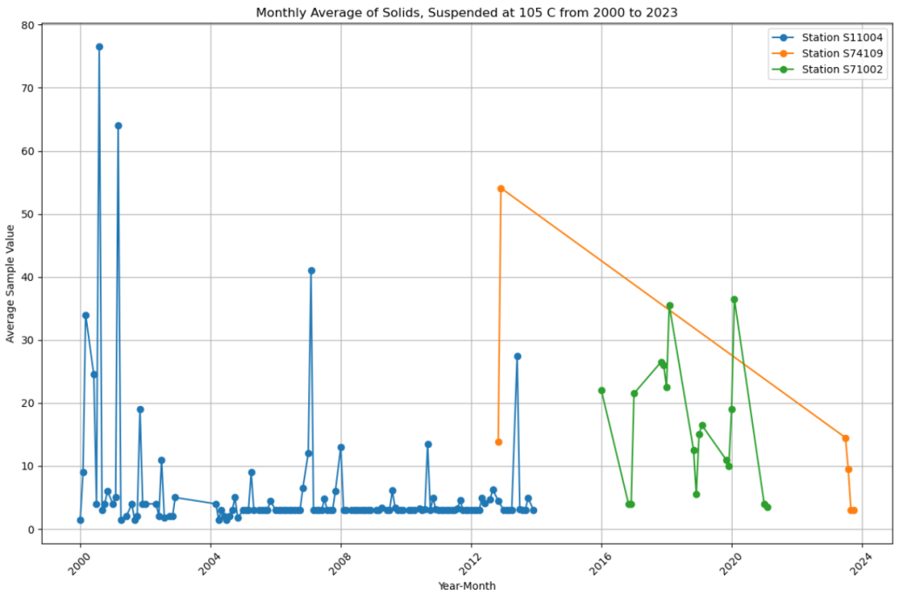

Temperature of Water: The temperature of water changes with the change of seasons, and the change trend of the three stations is the same.

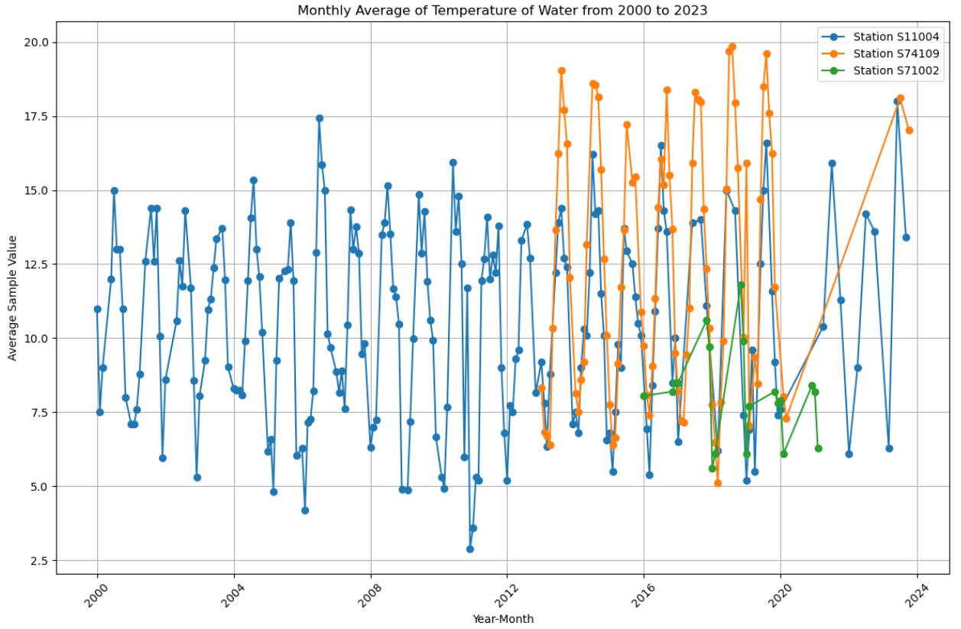

Oxygen, Dissolved, % Saturation: The variation trend of dissolved oxygen in the upper, middle, and lower reaches is basically the same, but the dissolved oxygen in the lower reaches is much less than that in the upper reaches.

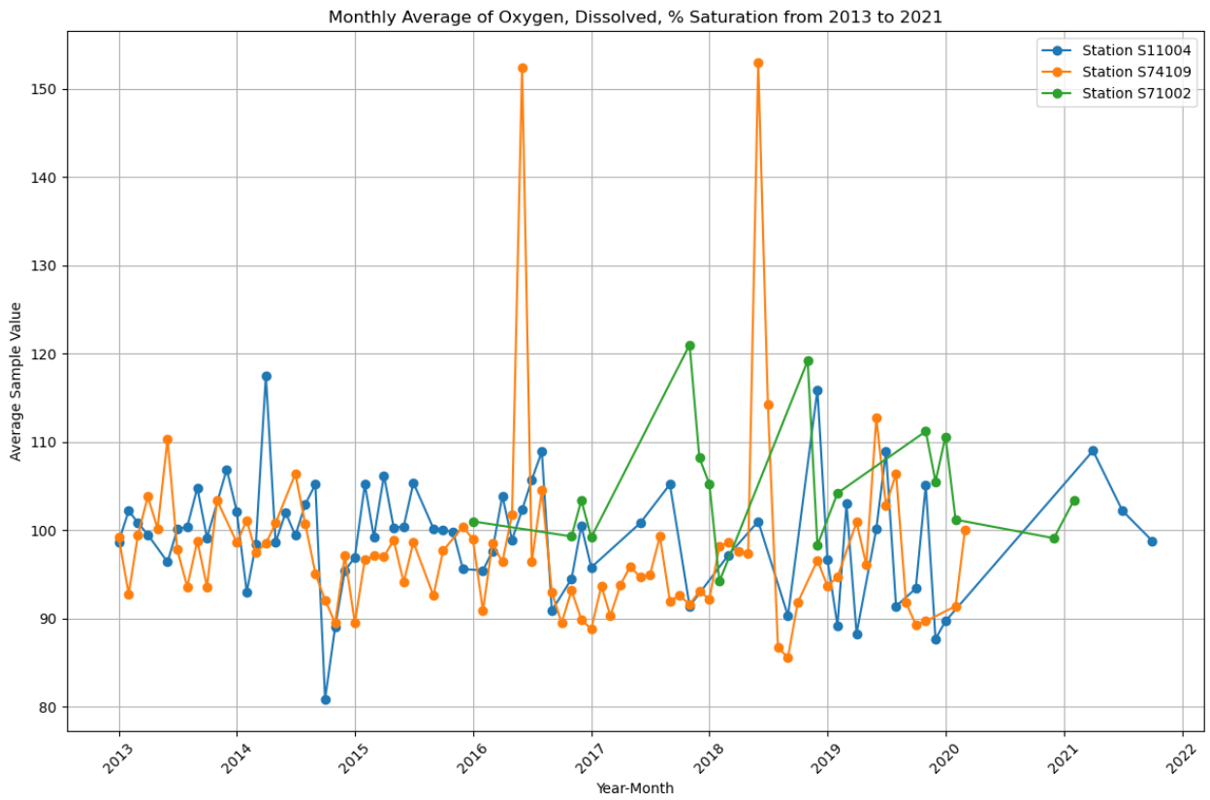

(2) Measurement parameters shared by upstream and downstream (10) :

Copper, Dissolved copper: the dissolved copper content in the upstream is significantly higher than that in the downstream, and the dissolved copper content in the downstream also increases when the upstream is increased. When the upstream content is reduced, the downstream will also be reduced.

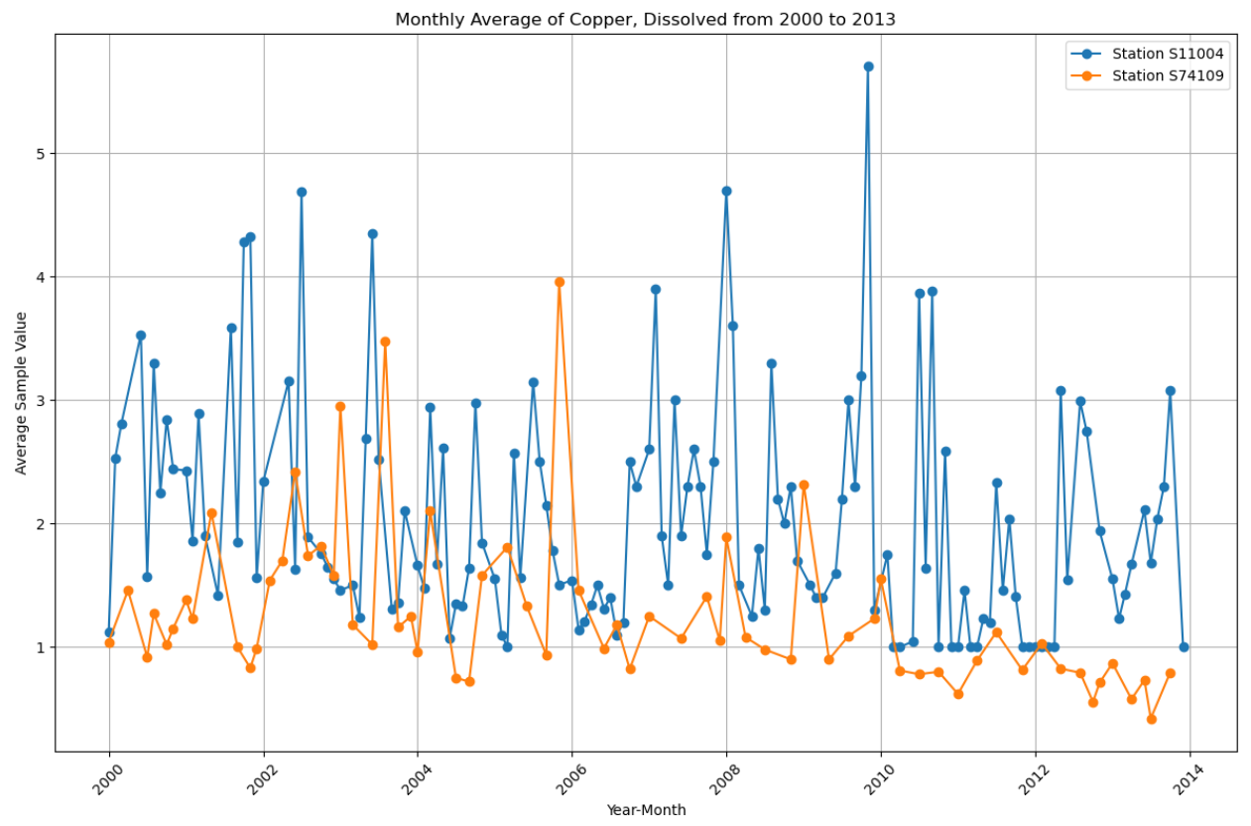

Calcium (dissolved calcium) : The calcium content is significantly higher downstream than upstream.

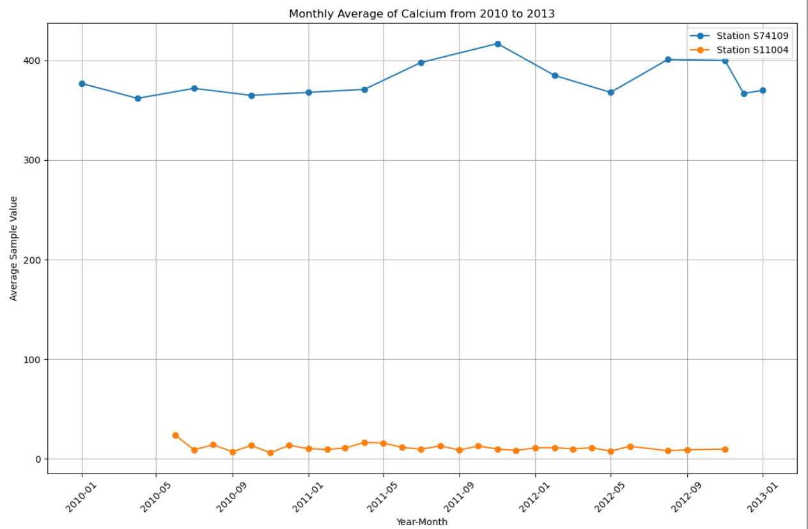

Solids, Suspended at 105 C

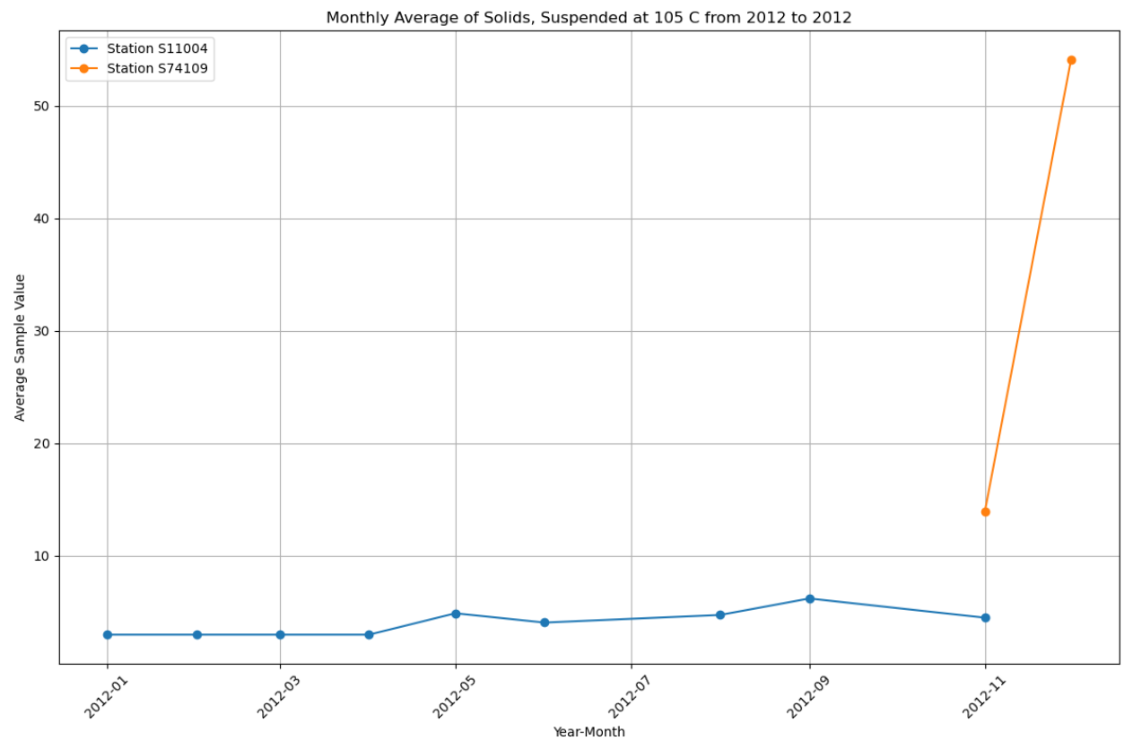

Magnesium: The content of magnesium downstream is significantly higher than that of upstream. (In natural bodies of water, magnesium usually ranges from 0.5 to 150 mg/L). The magnesium content of site S74109 is too high

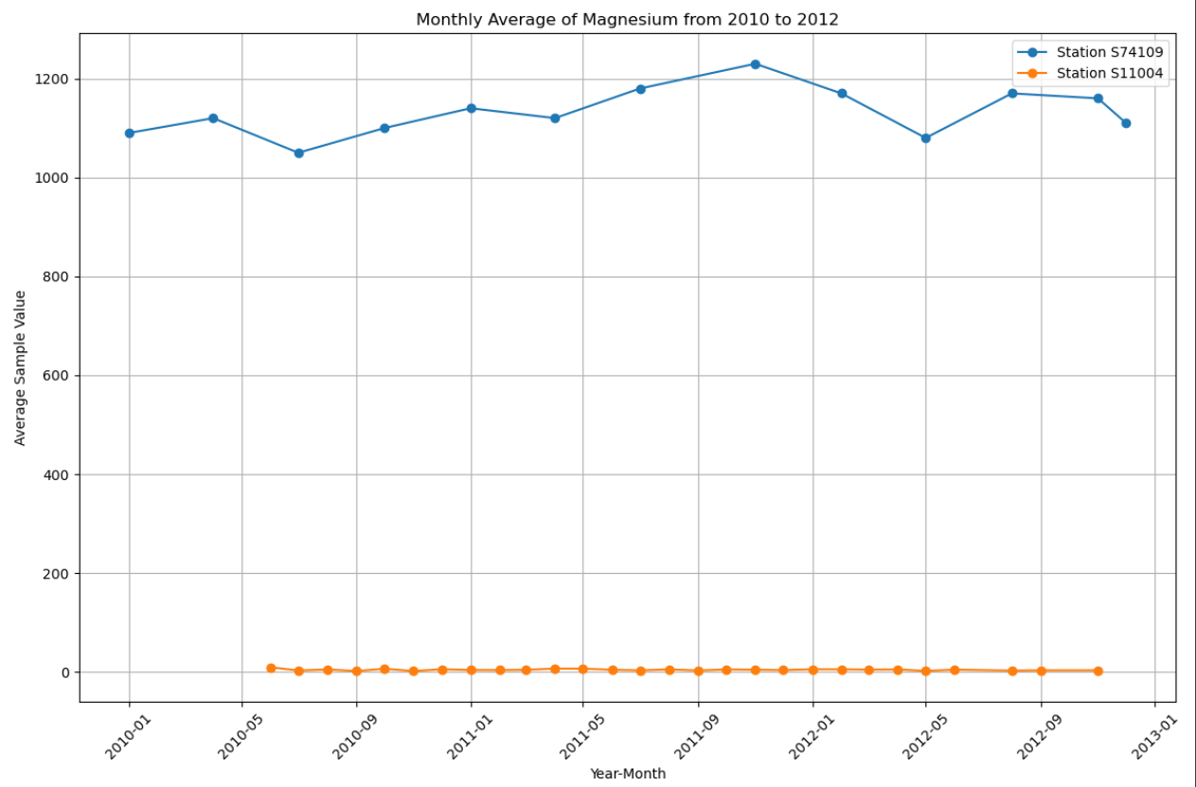

pH: In Situ: The downstream site (S74109) measured only once (content 8), the upstream site (S11004) measured values in the range of (7.24-8.01)

pH: The trend of water change up and down is close to the same. The downstream water is more alkaline than the upstream water, the upstream water is close to neutral water, and the downstream water is close to alkaline water.

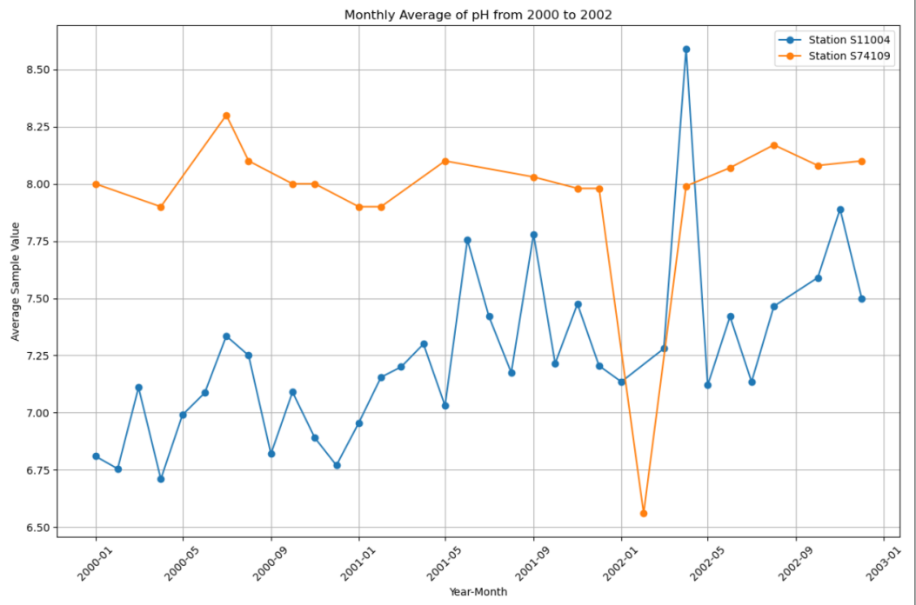

Carbon, Organic, Dissolved as C :- {DOC} : The dissolved organic carbon in the upstream is more than that in the downstream, and the content of organic carbon in the upstream will affect the content of organic carbon in the downstream.

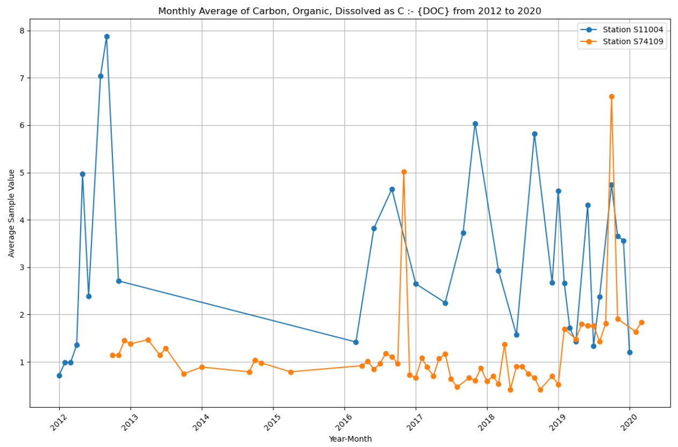

Iron, Dissolved: The dissolved iron content in the upstream is higher than that in the downstream, and the dissolved iron content in the upstream is greatly changed. The iron content in the lower reaches is small, and the change is small, relatively stable.

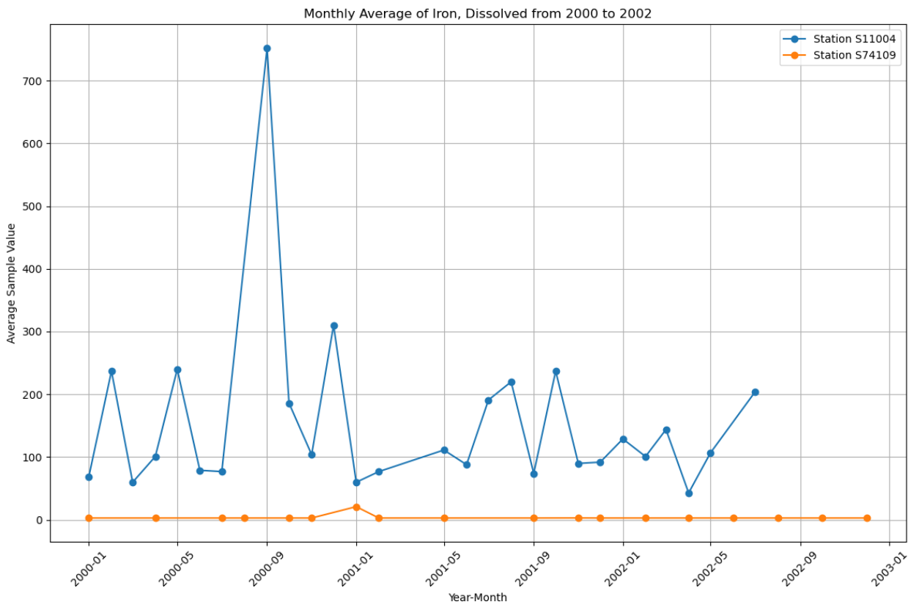

Oxygen, Dissolved, % Saturation: The variation trend of the dissolved oxygen in the upstream and downstream is basically the same, but the dissolved oxygen in the downstream is less than that in the upstream.

